Design Brief

Understand – be caring, ask questions and define the challenge
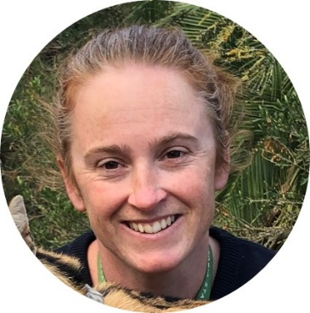
Meet Your User: Samantha Copland
I’m Samantha – the Shop Manager at Werribee Zoo. My job is to make sure that my team is providing good customer service and selling products that helps visitors and wildlife. The income made from the products we sell at the Shop pays for the care of animals at the zoo and in the wild. I am always looking for new product ideas that help endangered animals.

This year, I need product ideas that will raise money for African Wild Dogs.

Your product needs to:
- Educate or connect people to African Wild Dogs
- Be designed for a specific group of people e.g. parents, children, elderly people
- Be made of environmentally-friendly material
- Be sold at a price that is affordable for visitors

You will need to do research at school and at the Zoo.

Ideate – imagine creative solutions
It’s time to choose which challenge you’d like to solve. Work in a team of up to 6 people and brainstorm your ideas to solve the challenge. Choose one idea to try.
Prototype – show your idea by using what is available
A prototype shows your idea to other people. It can be a 3D model or you can make a workable prototype that can be tested. Use what you have got at school and home.
Test and Refine – test, share, evaluate and improve your prototype
Test your prototype by explaining it to other people or test your prototype in a real situation.
The goal is to get feedback so you can then improve your prototype.

Share your idea
If you would like to share your idea with me and my team, enter the STEM Design Challenge competition. Create a video of up to 2 minutes that explains your learning and how your prototype works. Enter at www.zoo.org.au/education/enter-the-stem-design-challenge/

Judging Criteria
This Judging Criteria will be used for the STEM Design Challenge competition.
Criteria | 1 Point | 2 Points | 3 Points | 4 Points
1. Understand  What is the challenge and who is the user? | Neither the challenge nor the user was described. | The challenge or the needs of the user was described. | Both the challenge and the needs of the user were described. | The challenge and the needs of the user were described, including personal insights that showed deep thinking.
2. Ideate  What were your ideas and how did you decide which one to prototype? | The process of ideation was not described. | Limited description of the process of ideation. | The process of ideation was described, along with a few ideas. | The process of ideation was described, including how a decision was reached on what idea to prototype.
3. Prototype  How did you create your prototype and how will it help the user solve the challenge? | The prototype was not complete. | The process of creating the prototype or how it works was described. | Both the process of creating the prototype and how it works was described. | Both the process of creating the prototype and how it works was described in detail e.g. material, safety
4. Test and Refine  How did you test your prototype and what modifications did/could you make? | No testing or refining of prototype was described. | The testing or the refinement of the prototype was described. | Both the testing and the refinement of the prototype was described. | Both the testing and the refinement of the prototype was described, including detailed description of modifications.
5. Bonus Points
- Description of how STEM knowledge and skills were applied
- Demonstration of creative thinking
- Demonstration of team work
- Suitability of prototype for the user
- Sustainability of materials used

