**STEM Design Challenge – Animals at Home**

**Teaching Guide**

**Introduction**

The STEM Design Challenge excursion program has been temporarily transformed into part of Zoo Education Online! This unique program involves F-10 students in solving real-world zoo challenges. Your students will find solutions to complex problems using their STEM skills, knowledge and an engineering framework called Design Thinking. They will bring their ideas to life using the materials around them and they are invited to share what they create with their peers and Zoos Victoria.

**Support for You and Your Students**

**Need some extra help?**  
Join the [Zoos Victoria Teacher Tribe](http://www.facebook.com/groups/zvteachertribe/) on Facebook to chat with zoo staff and other teachers.

Zoos Victoria is here to help you and your students by providing:

* This step-by-step Teaching Guide
* Student workbooks in MS Word format
* YouTube videos, including Animals at Home live streams
* Student webinars (so they can chat with zoo experts)

Here are two ways to use the STEM Design Challenge in your teaching:

1. Add to your own learning system – download MS Word docs, copy/embed YouTube links

2. Send students directly to Zoos Victoria’s website for MS Word doc instructions and links

**What Students Will Learn**

* How to research a big STEM problem
* How to combine STEM knowledge and skills through the sequence of Design Thinking
* How to brainstorm ideas and choose one to try
* How to visually show an idea to others
* How to test and refine an idea

**Stages of Design Thinking**

Here is what your students will be doing during each stage of Design Thinking:

|  |  |  |  |
| --- | --- | --- | --- |
| **Understand**  **Page 4-6**  Researching and asking questions | **Ideate**  **Page 7**  Brainstorming solutions | **Prototype**  **Page 8**  Building their  design | **Test and Refine**  **Page 9-10**  Testing and improving their design |

The Design Thinking process is not linear – students may need to return to different stages in order to deepen their understanding or try a new design idea.

**Victorian Curriculum Links**

Here is how you might use the STEM Design Challenge to teach the Victorian Curriculum:

|  |  |  |
| --- | --- | --- |
| **Level** | **Learning Area** | **Content Descriptor** |
| F-2 | Science | Living things have a variety of external features and live in different places where their basic needs, including food, water and shelter, are met |
| F-2 | Design and Technologies | Visualise, generate, and communicate design ideas through describing, drawing and modelling |
| F-2 | Critical and Creative Thinking | Identify, describe and use different kinds of question stems to gather information and ideas |
| 3-4 | Science | Different living things have different life cycles and depend on each other and the environment to survive |
| 3-4 | Design and Technologies | Generate, develop, and communicate design ideas and decisions using appropriate technical terms and graphical representation techniques |
| 3-4 | Critical and Creative Thinking | Investigate a range of problem-solving strategies, including brainstorming, identifying, comparing and selecting options, and developing and testing hypotheses |
| 5-6 | Science | Living things have structural features and adaptations that help them to survive in their environment |
| 5-6 | Design and Technologies | Generate, develop, and communicate design ideas and decisions using appropriate technical terms and graphical representation techniques |
| 5-6 | Critical and Creative Thinking | Investigate how ideas and problems can be disaggregated into smaller elements or ideas, how criteria can be used to identify gaps in existing knowledge, and assess and test ideas and proposals |
| 7-8 | Science | Science and technology contribute to finding solutions to a range of contemporary issues; these solutions may impact on other areas of society and involve ethical considerations |
| 7-8 | Design and Technologies | Generate, develop and test design ideas, plans and processes using appropriate technical terms and technologies including graphical representation techniques |
| 7-8 | Critical and Creative Thinking | Consider how problems can be segmented into discrete stages, new knowledge synthesised during problem-solving and criteria used to assess emerging ideas and proposals |
| 9-10 | Science | Scientific knowledge and understanding of the world changes as new evidence becomes available; science knowledge can develop through collaboration and connecting ideas across the disciplines and practice of science |
| 9-10 | Design and Technologies | Apply design thinking, creativity, innovation and enterprise skills to develop, modify and communicate design ideas of increasing sophistication |
| 9-10 | Critical and Creative Thinking | Investigate the kind of criteria that can be used to rationally evaluate the quality of ideas and proposals, including the qualities of viability and workability |

**Assessment**

At the end of the Design Challenge, students will create a prototype of their idea. They could create a video, present their idea to classmates, create a learning journal etc. You are welcome to use/edit this rubric to help students reflect on their learning and the Design Thinking process.

|  |  |  |  |  |
| --- | --- | --- | --- | --- |
| **STAGE** | **1** | **2** | **3** | **4** |
| **1. Understand**  What is the Challenge and who is the User? | Neither the Challenge nor the User was described. | The Challenge or the needs of the User was described. | Both the Challenge and the needs of the User were described. | The Challenge and the needs of the User were described, including personal insights that showed deep thinking. |
| **2. Ideate**  What were your ideas and how did you decide which one to prototype? | The process of ideation was not described. | Limited description of the process of ideation. | The process of ideation was described, along with a few ideas. | The process of ideation was described, including how a decision was reached on what idea to prototype. |
| **3. Prototype**  How did you create your prototype and how will it help the User solve the Challenge? | The prototype was not complete. | The process of creating the prototype or how it works was described. | Both the process of creating the prototype and how it works was described. | Both the process of creating the prototype and how it works was described in detail e.g. material, safety |
| **4. Test and Refine**  How did you test your prototype and what modifications did/could you make? | No testing or refining of prototype was described. | The testing or the refinement of the prototype was described. | Both the testing and the refinement of the prototype was described. | Both the testing and the refinement of the prototype was described, including detailed description of modifications. |
| **5. Bonus Points** | | | | |
| * Description of how STEM knowledge and skills were applied * Description of how creative thinking was applied * Suitability of prototype for the User (see Design Brief) * Sustainability of materials used | | | | |

**Design Thinking – Understand**

You are welcome to adapt these activities to suit the needs of your students.



**Start Here 🡺 Design Brief**

**Students will learn about the Challenge and the stages of Design Thinking.**

**Preparation:**

* Visit Zoos Victoria’s website to read each Design Brief – [www.zoo.org.au/education/stem-design-challenge-animals-at-home](http://www.zoo.org.au/education/stem-design-challenge-animals-at-home)
* Decide which Design Brief/s you’d like your students to work on

**Instructions:**

1. Students read through the Design Brief/s by themselves or with an adult so they can get to know the User, their Challenge and the stages of Design Thinking.
2. Ask students to think about what strategies they will use to understand the Challenge  
   e.g. stepping into the shoes of the User, asking questions during a webinar, researching on YouTube and the Internet
3. If you are planning on assessing the STEM Design Challenge, now would be a good time to discuss it, or co-create it, with your students.



**Animal Smarts Podcast**

**Students will listen to a Zoos Victoria’s Fauna podcast (20 minutes long).**

**Preparation:**

* Visit Zoos Victoria’s website to download the Student Workbook – [www.zoo.org.au/education/stem-design-challenge-animals-at-home](http://www.zoo.org.au/education/stem-design-challenge-animals-at-home)
* Give your students access to the Fauna Podcast ‘Animal Smarts’ episode via Zoos Victoria’s website ([www.zoo.org.au/education/fauna-podcast/](http://www.zoo.org.au/education/fauna-podcast/)) or podcast app.

**Instructions:**

1. Listen to the Fauna Podcast episode called ‘Animal Smarts’ (20 minutes in length)
2. Answer these questions:
   * How do Melbourne Zoo keepers look after animals’ health?
   * Why is it important to let animals make their own choices?
   * Write one question you have about how Melbourne Zoo cares for animals.

The Student Workbook includes a Research page for students to record what they learn.

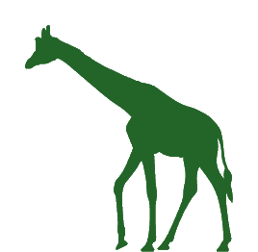**Enrichment at Home**

**Students will investigate human and pet enrichment in their home.**

**Preparation:**

* You are welcome to use the Student Workbook for this activity – [www.zoo.org.au/education/stem-design-challenge-animals-at-home](http://www.zoo.org.au/education/stem-design-challenge-animals-at-home)

**Instructions:**

Enrichment helps an animal:

1. use its senses e.g. smell, touch, taste, see, hear
2. move in natural ways e.g. walk, run, jump, fly
3. behave in natural ways e.g. sleep, eat, communicate

Ask students to walk around their home. What enrichment can they see for the people and/or pets who live there? The Student Workbook has a section for students to record what they see.



**Zoo Live Streams**

**Students will watch their chosen animal on the Animals at Home live stream.**

**Preparation:**

* You are welcome to use the Student Workbook for this activity.
* Animals at Home live streams are found at [www.zoo.org.au/animal-house/](http://www.zoo.org.au/animal-house/)

You can send students directly to the website or right-click on any of the videos to get a link or embed code for your own learning system.

**Instructions:**

Just like a scientist would, students watch the live stream of the animal in its zoo habitat. If there are no animals to be seen, ask students to rewind the live stream video and search for a time where the animal are there.

Students should use their scientific observation skills to learn:

1. How the animal is using its senses
2. How the animal is moving
3. How the animal is behaving

Students should also look for enrichment that is already in the zoo habitat

e.g. food, logs, rocks, toys

The Student Workbook includes a Research page for students to record what they learn.



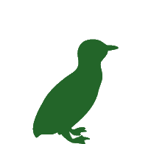**Zoos Victoria Webinars**

**Students will talk to a zoo expert.**

**Preparation:**

* Visit Zoos Victoria’s website to see upcoming webinar dates and/or   
  links to previously recorded sessions   
  – [www.zoo.org.au/education/stem-design-challenge-animals-at-home](http://www.zoo.org.au/education/stem-design-challenge-animals-at-home)
* Students will need headphones or a way to listen to the zoo expert
* If watching live, students will need a keyboard to type their questions

**Instructions:**

Zoos Victoria’s webinars are free for any student. They are hosted via Adobe Connect, thanks to the Victorian Department of Education and Training. Your students can join the webinar via the website link or using the Adobe Connect app. No username or password is needed.

Students will not be on-screen during the webinar. They are encouraged to type their message in the Chat area and the zoo expert will answer as many questions as possible.

These webinars will also be recorded so anyone can watch at a time that suits them. Links to previously recorded sessions are available on the website.

The Student Workbook includes a Research page for students to record what they learn.



**Extra Research**

**Students will do more research by watching videos and searching the Internet.**

**Preparation:**

* You are welcome to use the Student Workbook for this activity.
* We’ve built a student-friendly playlist on YouTube. You can send them directly to YouTube or share the playlist on your learning online system – [www.youtube.com/playlist?list=PLq_FuJlj2gUygvNzFkAYCmNAhDbksGEoW](http://www.youtube.com/playlist?list=PLq_FuJlj2gUygvNzFkAYCmNAhDbksGEoW)
* You could also let students loose on Google or ask them to use a list of preferred websites

**Instructions:**

Now is the time for students to do their final bit of research before brainstorming their solution ideas. Ask them to think about what they still need to find out – did they find answers to their questions?

They could:

* Watch Zoos Victoria’s playlist on YouTube –
* Research on Google or your preferred search engine
* Use a list of your preferred websites e.g. National Geographic Kids – [www.natgeokids.com/au/](http://www.natgeokids.com/au/)

The Student Workbook includes a Research page for students to record what they learn.

**Design Thinking – Ideate**

You are welcome to adapt these activities to suit the needs of your students.



**Start Here 🡺 100 Ideas in 10 Minutes**

**Students will write a list of ideas that might help to solve the Challenge.**

**Preparation:**

* You are welcome to use the Student Workbook for this activity.
* Students will need their Design Brief and their research notes from the Understand stage
* Students will need a pen/pencil or an ability to type out their ideas
* Students will need a timer for this activity

**Instructions:**

1. Students should re-read their Design Brief and their Understand research notes.
2. Now it’s time for students to imagine lots of ideas that will solve the Challenge. They have 10 minutes to write down as many ideas as possible... the goal is 100!
3. Explain to students that the sky is the limit, there is no such thing as a bad idea during Ideate. Encourage them not to give up if it gets tricky – their brain will kick in again after a small break.
4. Students set their timer to 10 minutes and start writing their ideas down.
5. When the timer reaches 10 minutes, students stop writing and count up how many ideas they thought of.



**Choose Your Idea**

**Students will choose one design idea to prototype.**

**Preparation:**

* You are welcome to use the Student Workbook for this activity.
* Students will need their ideas list from the ‘100 Ideas in 10 Minutes’ activity
* Students will need a way to search the Internet (optional)

**Instructions:**

1. Students look through their ideas list and choose their ‘Top 5’. These are the five ideas that they like the most.
2. Students now need to look at their Top 5 more closely. Are the ideas similar? Do they have things in common? Is there a way to mash ideas together?
3. Also ask students to think about the time they have to create their prototype (set by you) and what materials/technology they’re going to use.
4. Once students have chosen an idea, ask them to do a fast check in the Internet. Has someone already thought of this idea? Did it work? Can it be improved?
5. Ask students to keep their ideas list somewhere safe. Designers use a growth mindset and return to their ideas list if their first chosen idea doesn’t work out.

**Design Thinking – Prototype**



**Build Your Idea**

**Students will build their idea so that others can see it.**

**Instructions:**

Students are welcome to use new technology and/or older technology to build a prototype and show their idea.

You may need to help students identify what materials or technology they have to build their prototype. For example:

* Recycled cardboard boxes
* Playdough or clay
* Lego
* Natural materials found in the garden
* Paper, glue and craft materials
* Sketches and diagrams on paper
* Microsoft Office or Adobe suite
* Drawing or animation apps

Encourage students to:

* Design for the User as well as their challenge (and the animal they’re working with).
* Return to the Ideate stage (and their ideas list) if their prototype isn’t going to work.
* Return to Understand stage and do more research if they still have questions.

Here are some examples of student prototypes:

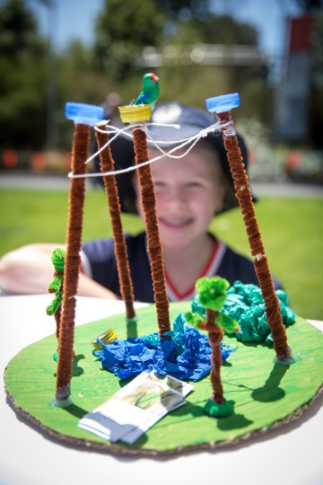 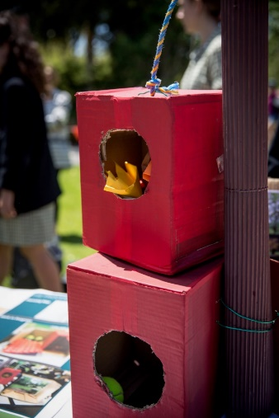

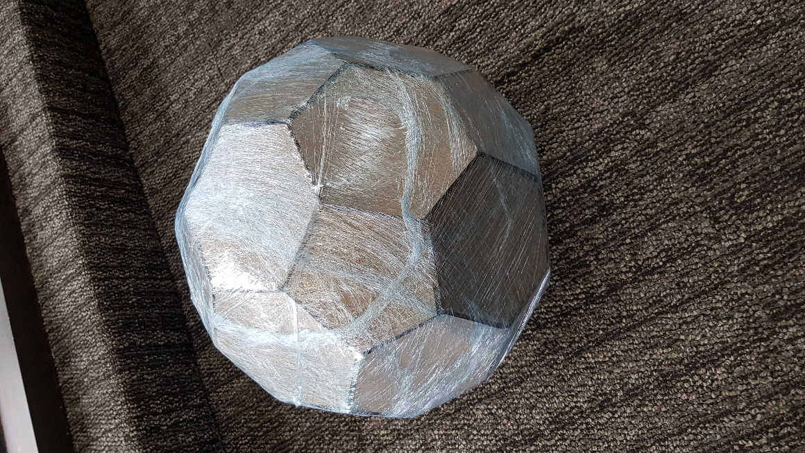

**Test and Refine**

Choose how you’d like students to test and refine their prototypes. Here are some ideas.



**Start Here 🡺 Test Your Design**

**Students will test their prototype by getting feedback from others.**

**Preparation:**

You might need to help students find an audience to give feedback on their prototype. It could be their classmates, someone in their home, a family member or friend via video call or their teacher.

**Instructions for Presentation:**

Students may need to practice how they will present their prototype to others and get feedback. The assessment rubric on page 3 of this teaching guide suggests what students could include a presentation or learning reflection.

This presentation could be in a video format and later uploaded to YouTube (see ‘Share Your Prototype’ activity on page 10) or uploaded to **your learning online system**.

After presenting their prototype, students should ask their audience questions like:

* Does my prototype solve the Challenge?
* Does my prototype work for the User?
* How could I improve my prototype?



**Refine Your Design**

**Students will improve their prototype design by using the feedback they received.**

**Instructions:**

A designer does not get it right the first time. They have to play with and change their prototype so it can better solve the challenge. Once students have received feedback during the Test stage, they should make improvements to their design. They are then welcome to return to re-test their prototype, based on their new design.

What should students do if they want to share their prototype with Zoos Victoria? The next activity (Share Your Prototype) is optional and provides instructions on how to upload a video to YouTube.





**Share Your Design (optional)**

**Students will use a YouTube video to share their design with other people and Zoos Victoria.**

Students are welcome to create a short video to share on YouTube. They could:

* Choose to be in front or behind a video camera to explain their prototype
* Create a narrated PowerPoint or slide deck in a video format
* Use an app of their choice to create a video

**Instructions:**

1. Students need a YouTube or Google account (or that of their parent/guardian).

2. After logging in, they can upload their video.

Here are instructions from YouTube – [www.youtube.com/watch?v=klVWGHtRTuE](http://www.youtube.com/watch?v=klVWGHtRTuE)

3. Students have a few YouTube Privacy setting choices:

* Unlisted – their video won’t be listed in YouTube online searches
* Public – their video will be listed in YouTube and online searches
* ‘No, it’s not made for kids’ – Zoos Victoria and others will be able to comment on their video
* ‘Yes, it’s not made for kids’ – no one will be able to comment on their video

Note: if the video setting is ‘private’, only the student will be able to see it

4. Students then complete the form on Zoos Victoria’s website

– [www.zoo.org.au/education/stem-design-challenge-animals-at-home](http://www.zoo.org.au/education/stem-design-challenge-animals-at-home)

The form asks students whether a parent/guardian has given them permission to share their video.

Their video might be added to Zoos Victoria’s student designs YouTube playlist.

**Need some extra help?** Join the Zoos Victoria Teacher Tribe Facebook group to chat with zoo staff and teachers from other schools – [www.facebook.com/groups/zvteachertribe/](http://www.facebook.com/groups/zvteachertribe/)



This program is funded by the Department of Education and Training’s Strategic Partnerships Program.



This program is funded by the Catholic Education Commission of Victoria.

cid:image002.png@01D5B01A.B30DEC10Zoos Victoria acknowledges the Traditional Custodians of the land on which we live and work, and pay our respects to Elders both past and present.