We would love to hear your students’ stories and celebrate their success! Find instructions below on how your students can share their stories with Zoos Victoria.

Students can share a video of their story with Zoos Victoria and other schools.

If your students would like to share their story with Zoos Victoria and people from other schools, or find out what others have created, they can join Zoos Victoria’s Flipgrid.

Flipgrid is a free Microsoft platform specifically designed for learners to share their ideas, stories and work. Students can record their video using:

- Flipgrid website, using the camera on their laptop or computer
- Flipgrid’s app (available for Apple and Android), using the camera on their phone or tablet

Instructions:

- Decide on the level of privacy. Students can present their story in front of the camera or narrate from behind the camera. Zoos Victoria’s Flipgrids are available to anyone who has the URL and password. Please refer to your school’s privacy policy. If you need parent/guardian permission, here’s a sample form – https://static.flipgrid.com/docs/Flipgrid_consent_form.pdf
All videos will be approved by a moderator before being visible to others.

- Give students the URL and password for their website browser or Flipgrid app.
URL – https://flipgrid.com/zvlocals
Password – Localanimals

3. Students are welcome to watch the videos already in the grid. If they want to share their design and record their own video, here is what to do (instructions are also on this webpage).
Click the green plus symbol to get started.
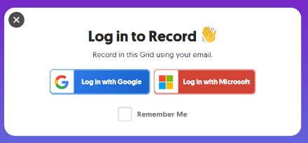
Students will need to log in using their Google or Microsoft password. At least one these accounts is probably already linked to their Catholic Education, Department of Education or independent school email address.

Tap the record button on the bottom to start. If students are using a web browser, they made may need to enable Adobe Flash Player. They can add fun stickers, filters, text, and more.

Review the video – trim, rearrange, or add more.

Take a thumbnail photo for the video. This could be a selfie or a photo of the prototype.
Students can edit their name, video title or attach a link. Then submit! They will get a confirmation email with a link to share with your class. They can also download their video.

You are welcome to visit this grid at any time to see what your students and others have created.
Getting Feedback:
Zoos Victoria staff will provide feedback on your students’ information report so they can improve their design. Other people in the Flipgrid might give feedback too. Your student will get an email notification when any feedback is provided.

New to Flipgrid? Here is some support:
- Student Privacy Pledge – http://blog.flipgrid.com/news/2017/5/19/flipgrid-student-privacy
- Help Centre – https://help.flipgrid.com/hc/en-us
- FlipGrid YouTube Channel – www.youtube.com/channel/UCaE_edn77lDzCxI3pinKvHg

Thank you for participating in Zoos Victoria’s Education Online.

Images

Zoos Victoria extends usage the following images for the specific educational purposes expressed in the Love Your Locals student webinar. Zoos Victoria holds copyright for all images in this document.

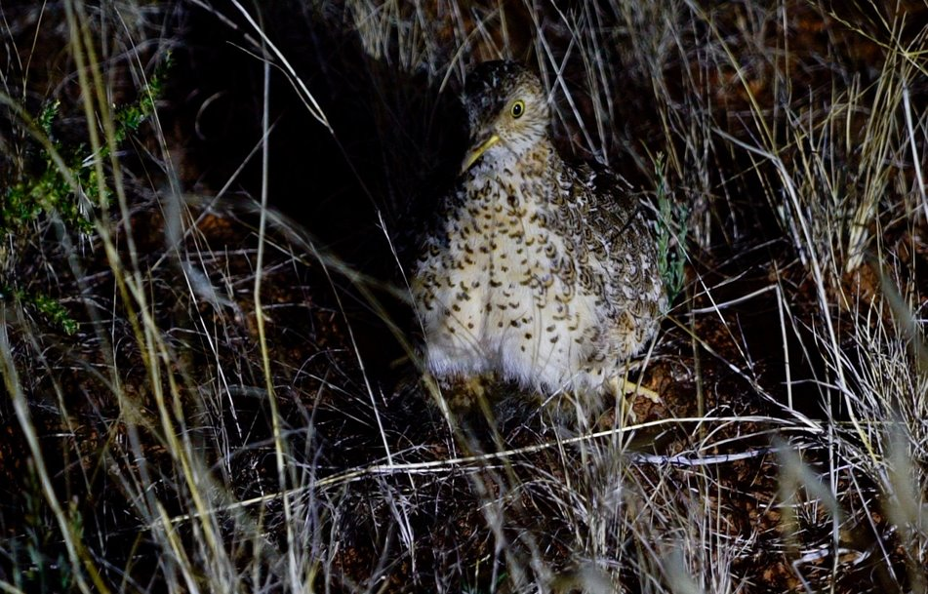
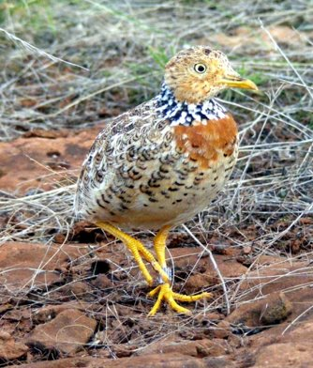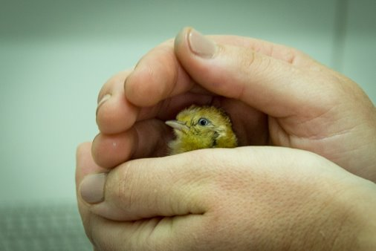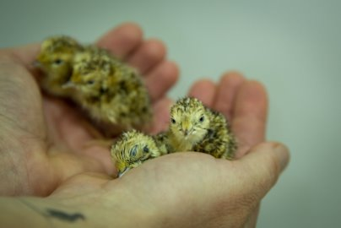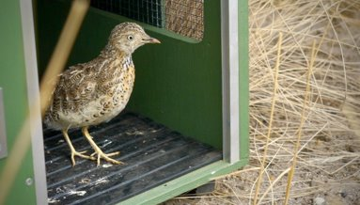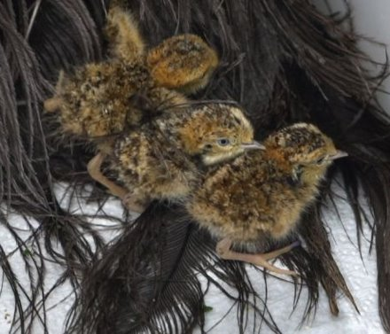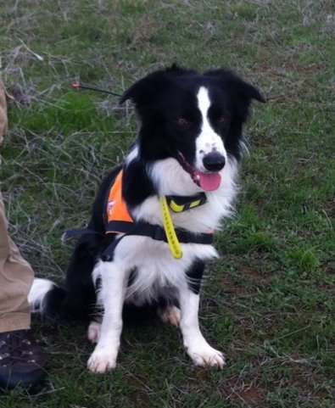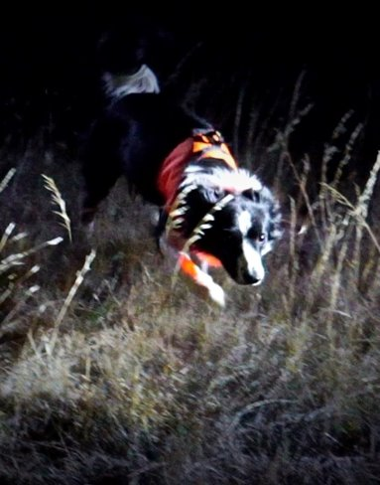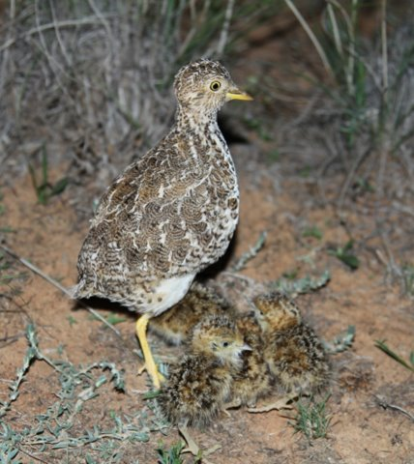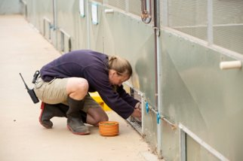
Extra Support
Got a question? Zoos Victoria’s education team is here to help you. Here is how to get extra support:

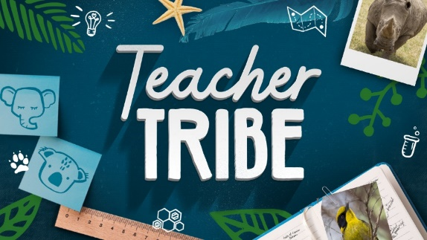
Teacher Tribe Facebook Group
Our Teacher Tribe is a community who use real-world learning to enable young people to thrive as learners and conservation change-makers. Use this Facebook group to share your stories, ideas and resources with zoo staff and teachers from other schools and get support for your teaching.

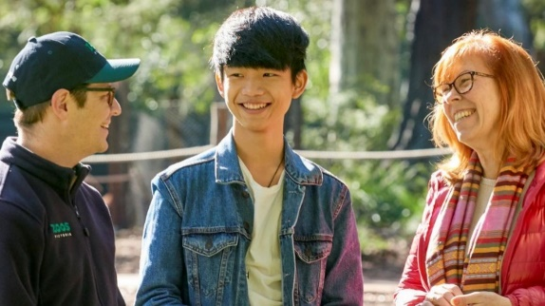
Teacher Membership and Professional Development
Become a Teacher Member to receive exclusive access to teacher professional development events, unlimited entry to our three great zoos, the education e-newsletter and all the benefits of a Zoos Victoria membership.

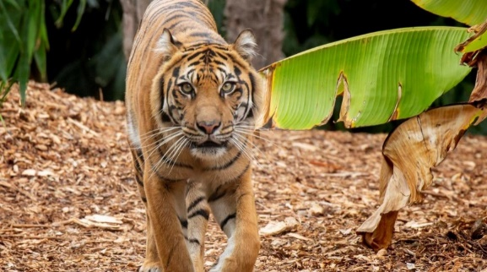
Zoo Education Online
Want to do another real-world learning unit with your students? Check out Zoo Education Online. We're bringing the zoo to you with learning activities, resources, webinars and live stream animals to help with real-world learning.

Zoos Victoria acknowledges the Traditional Custodians of the land on which we live and work, and pay our respects to Elders both past and present.

This program is funded by the Department of Education and Training’s Strategic Partnerships Program.

This program is funded by the Catholic Education Commission of Victoria.

